# Housing Prices in Canada during 1987

# DSC 323

# By: Jon Doretti

# 

# 

# 

# 

# 

# 

# 

# 

# 

# 

# 

# Table of Contents

# 1.0 - Introduction

Here you will learn about housing prices in 1987. These houses have been selected by the location and to further reduce the data set specific months. All houses will be from Windsor, Canada that were sold in the months of July, August and September. There are several variables that will be looked at: (1) Price, (2) Lot size, (3) Bedrooms, (4) Bathrooms, (5) Stories, (6) Driveway, (7) Recreation room, (8) Full basement, (9) Gas hot water heating, (10) Air conditioning, (11) Garage, (12) Location. Price will be the dependent variable as we will be trying to see how all other variables affect the price of a house. At initial glance some variables that seem to have a significant effect on the price are the lot size, bedrooms, bathrooms, stories, full basement and location. All of these variables share a common factor; each has to do with how much land is used, where the land is located and if the house is finished. As bedrooms and bathrooms increase in a house the price will rise and this increases the lot size with more space used therefore also increasing the price. A preferred location should also increase the price as a good location will have good education, parks, retail locations and public transportation. All highly sought after things, hence an increase in price. A full basement will also increase the price as this will eliminate work the new homeowner will need to do when they first move in; in other words, increasing the upfront price, instead of an expense after the purchase. Variables that could have an effect on price however are not significant are garage, air conditioning, gas hot water heating and driveway. I feel the garage and driveway vary depending on the location. If the location is very good with lots of public transportation then a driveway is not needed and street parking will suffice. Also a garage is not needed because if there is good public transportation only one car is needed and then street parking will also suffice. Air conditioning does have an effect however not significant as someone can buy an air conditioning window unit. Same applied to the hot water heater, a person can purchase an electric water heater as they had a post war boom in 1948 according to Barnes, making it widely available to people in 1987.

## 1.1 - Literature review

Based on articles the data from 1987 is skewed. During 1987 Canada saw a large boom in real estate. This is said by Robin Levinson King, who is a reporter for the Toronto Star. King said:

“the market soon recovered and then soared in the late ’80s In 1987, housing prices went through the roof to an average $189,105 ($354,117 in 2014 dollars) — a 29-per-cent increase in just one year”.

This means that this data is good for comparing between different assets a house has to offer based on our variables. Although, for comparisons between years we would need a different variable set as none of these real estate properties. This also means that the prices we have in 1987 are inflated as King also states:

“In 1990… housing prices tumbled 11 per cent as mortgage rates once again soared, this time to 14 per cent. The following year saw another big dive, when housing prices dropped 12 per cent. This slump continued for several more years”

Inflated prices can give us a skewed influence of different assets that the house has; for example, the number of bathrooms or bedrooms and their influence on the price. Jason Heath, who is a journalist at the financial post, touches on this and agrees with King. Heath states, “prices rose quickly from 1985 to 1989, fell through 1996”. This supports King, however, Heath takes it a step further; “[Real estate prices] have since been on a near straight line upwards”. In the articles it talks about interest rates and their effect on the prices of houses. Meaning that the variables that are currently being used are not a full picture of what affects housing prices.

“Interest rate declines have been the only thing that has kept home affordability in line with 1985, given that monthly mortgage payments relative to family income have only creeped up a little bit in the past 30 years.”

In other words, Heath is saying that the price of a house has been rising the past 30 years, from 1985 to now except from 1990 through 1996, due to the constant reduction of interest rates. Making homes more affordable allows more people to buy and further shrinking the supply and increasing demand. This means that interest rates may also have a significant effect on our dependent variable, price. Also during the 1980’s, Canada saw a slowing in population growth and a moving from multi-family homes to single family homes according to the Canadian statistics website.

# 2.0 - Methodology

The first step in curating the data to be usable is the creation of dummy variables. All observations in the data set were completely filled, therefore, the removal of entries within the observations was not necessary. Next variables with text as their entry were changed. There are six text variables within the data set: (1) driveway, (2) recreation, (3) fullbase, (4) gasheat, (5) aircon, and (6) prefer. There variables were turned into numeric values as all entities within the observations were either 1 for yes or 0 for no. Although for gas heat and prefer, yes entries were labeled as ‘ye’. The dummy variables created are called: (1) dummyDriveway, (2) dummyRecreation, (3)dummyFullbase, (4) dummyHeat, (5) dummyAir, and (6) dummyLoc.

The next step used price as the dependent variable, as stated before, to create a five-number summary, along with histograms and log transformation histograms. The use of scatterplots and correlation were also used. These graphs are used to visualize the data in a simplistic and informative way. Allowing for any reader to access and validate the findings. The analysis section consists of a full model, a model selection, a final model and two predictions. This is where outliers and influential observations are removed from the data set. Use of a Five-fold Cross-Validation model testing the validity of the data will be used too.

All graphs and models have been coded and created and will be included in the appendix. However, due to time constraints some figures in the appendix will not be discussed. This does not prevent use of these figures to further research within a different paper.

# 3.0 - Analysis, Results and Findings

In the original data set you can see that the histogram in Figure 1 shows a unimodal positively skewed histogram. This histogram seems to have a lot of outliers, however, as we found out later in the regression model there were nine outliers and influential observations: (1) Observation 103, (2) Observation 104, (3) Observation 185, (4) Observation 195, (5) Observation 239, (6) Observation 414, (7) Observation 466, (8) Observation 473, and (9) Observation 502. All of these observations were eventually removed from the data set. To offset the positive skew the use of a logistic transformation. In Figure 2 you can see the use of this logistic transformation. This created a very slight positive skewed unimodal histogram. This led me to believe that not many outliers lived within the data. Hence only 9 observations being removed from the data set. All of these findings are supported by the Five-number summary within the respective figures. The spread between the increments becomes closer when comparing figure 1 to figure 2. When looking at the scatter plots in figure 3 you can see some correlation and the concentration of a lot of observations. That is why I used Figure 4 in order to check the correlation - lot size, bedrooms, bathrooms, stories, and garage have a massive positive correlation to price. Location, air conditioning, full basement, and recreation all have a moderate positive correlation to price. Heat and driveway both have a slight positive correlation.

The correlation plays into the selection of significant variables. As all variables affected price in a positive way, I assumed that all variables would be considered significant. It was shown by looking at the Regression Model - Price of figure 5. Here you can see that all values for PR > |t| are less than the alpha test of .05. This means that all variables are considered significant. Allowing us to use all variables when preceding the final goodness of fit model. This model as discussed in the paragraph above only needed to be changed to remove the nine outliers and influencers. In figure 7, the F Value is 101.92 and a PR > F value of <.0001. This accompanied by a 65.31% ot .6531 Adjusted R-Squared confirms that this a good model and proves that all variables are significant again. The results and findings for the final model tell us that for every one dollar up in price every variable will increase as well. The most significant, from greatest to least, being Air, heat, location, bathrooms, full basement, stories, recreation, garage, bedrooms. The prediction variables that were added to the data set can be found in Figure 11 and the prediction intervals can be found in Figure 13.

For all testing and validation techniques, a 75%-25% split for Training to Testing was used. Based on the testing, training and validation using the five-fold cross-valuation, it was found that only lot size, bedrooms, bathroom, heat and air were significant variables. Within figure 17, the Root MSE is .21575; this is low. Although when looking at the Adjusted R-Squared one will find that the observation’s fluctuations are responsible for 66.54% or .6654. The Adjusted R-Squared value being this high is good. After, the use of the survey select method was used. Here, all variables were once again found significant. The Adjusted R-Value is once again high at a value of 61.85% or .6185. The model also passes the goodness-of-fit test all in Figure 21. In the images shown in Figure 22, all pass the all assumptions. The normality plot shows linearity with some slight variance. All these graphs and models have shown that all variables have significance when correlating to price. Some of the initial thoughts provided in the introduction were proven to be wrong as those variables played a more significant role in the price of a house in Canada in 1987.

# Sources

Barnes, Anthony. “Water Heater History (How Hot Water Has Evolved).” *Water Heater Hub*, 3 Nov. 2021, https://www.waterheaterhub.com/water-heater-history/.

Government of Canada, Statistics Canada. “Evolution of Housing in Canada, 1957 to 2014.” *Government of Canada, Statistics Canada*, 17 May 2018, https://www150.statcan.gc.ca/n1/pub/11-630-x/11-630-x2015007-eng.htm.

Heath, Jason. *Now and Then: Do Canadian Homes Really Cost That Much More than 30 ...* https://financialpost.com/personal-finance/mortgages-real-estate/now-and-then-do-canadian-homes-really-cost-that-much-more-than-30-years-ago.

King, Robin Levinson. “Toronto Housing Prices Nearly Triple since 1970s.” *Thestar.com*, Toronto Star, 5 Mar. 2015, https://www.thestar.com/news/canada/2015/03/04/toronto-housing-prices-nearly-triple-since-1970s.html.

# Appendix

# 

# 

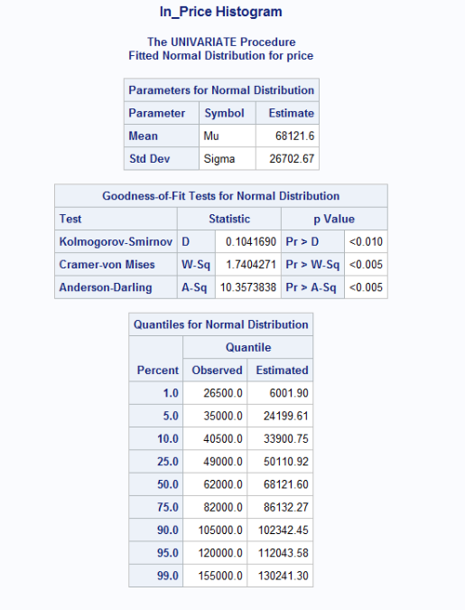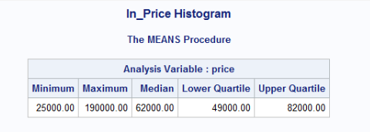

Figure 1

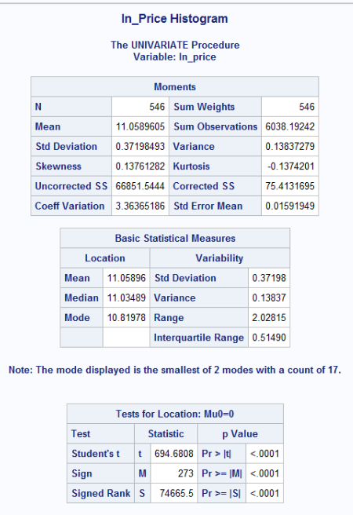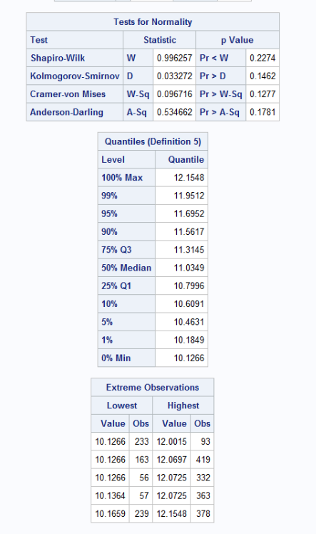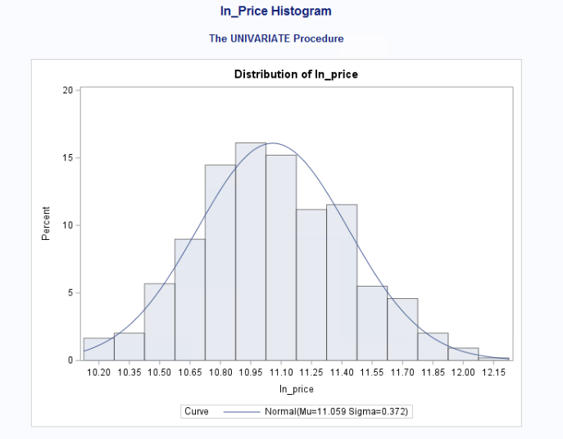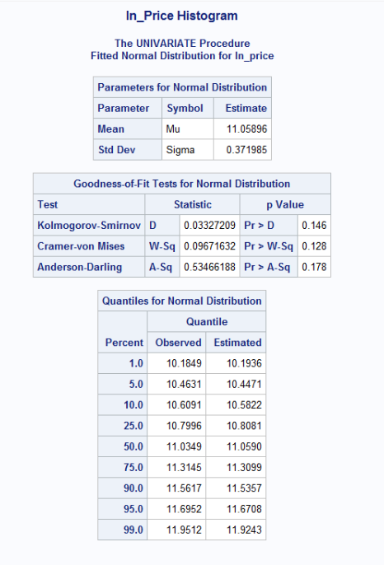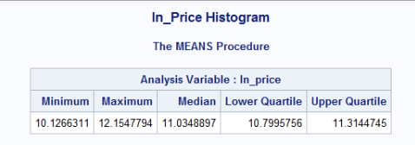

Figure 2

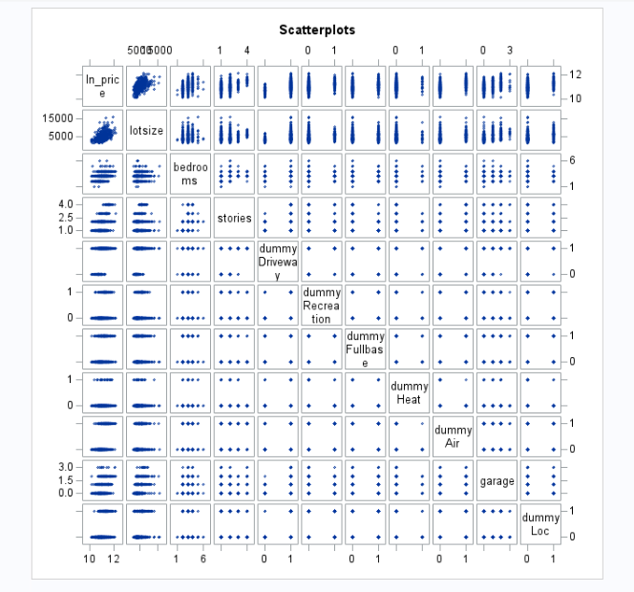

Figure 3

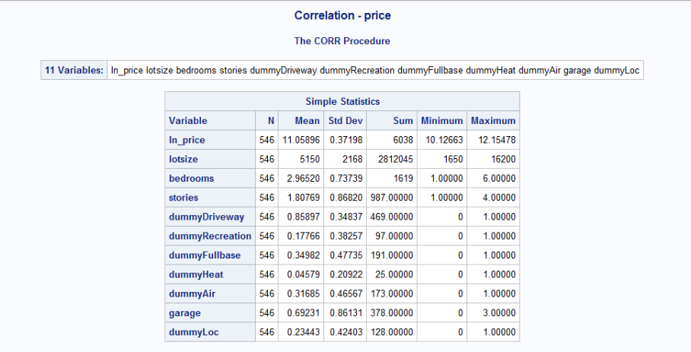

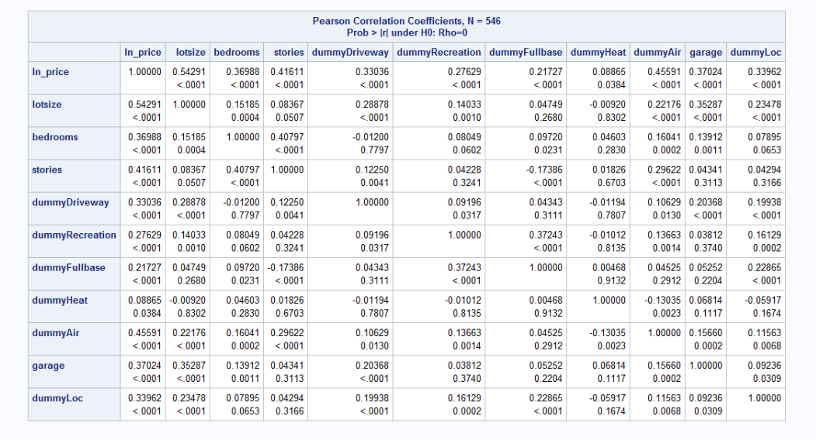

Figure 4

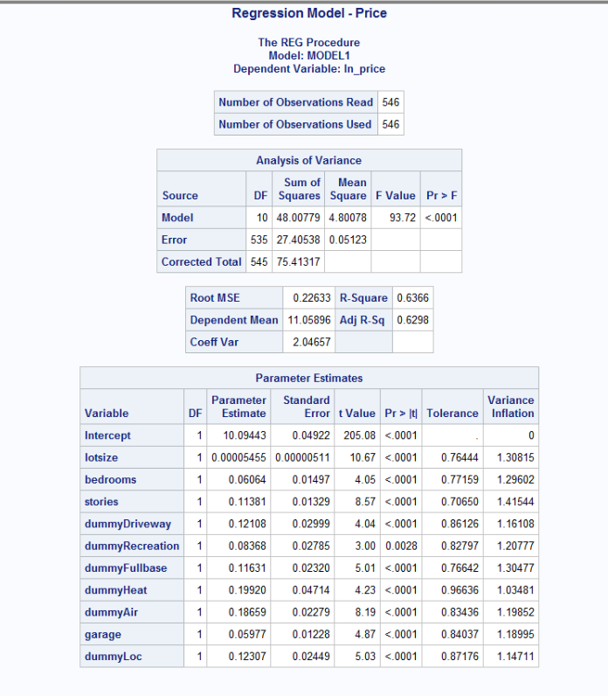

Figure 5

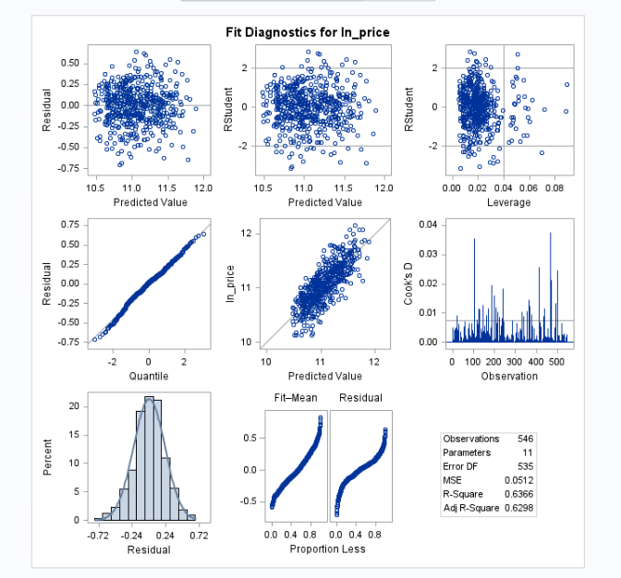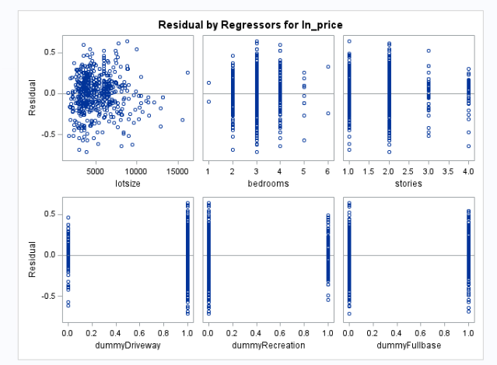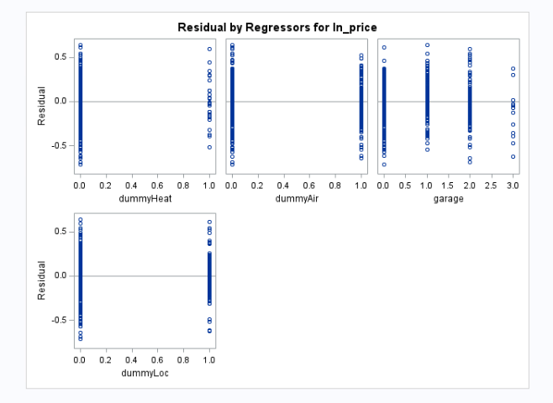

Figure 6

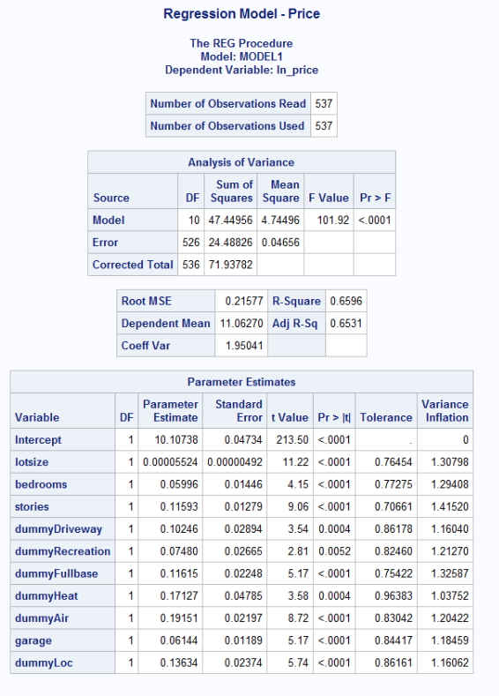

Figure 7

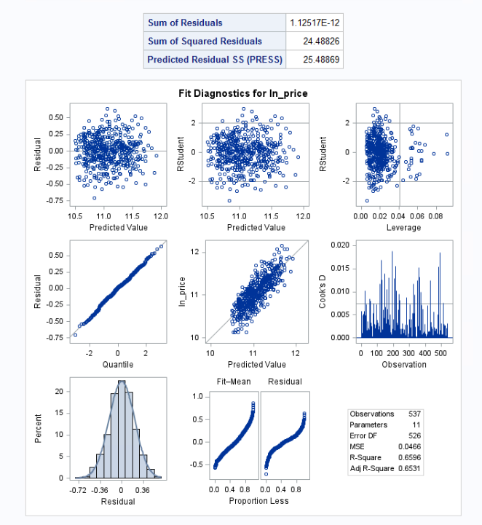

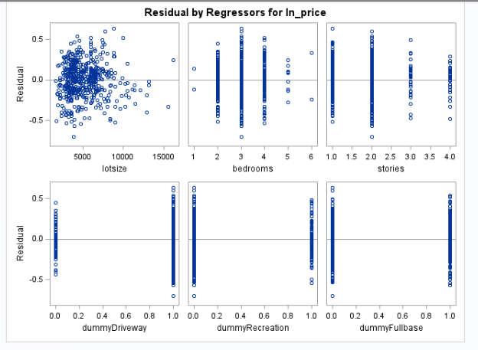

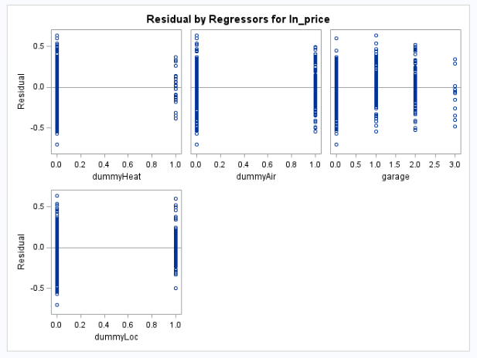

Figure 8

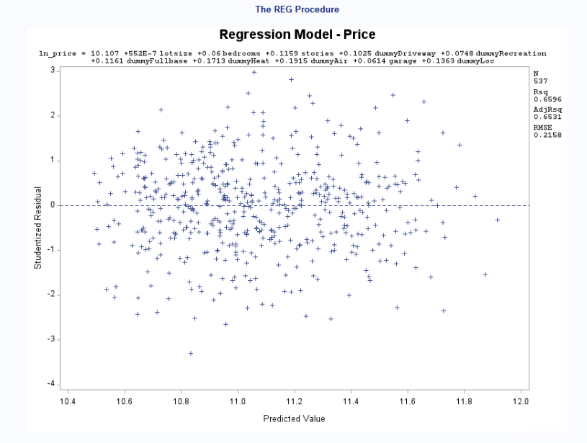

Figure 9

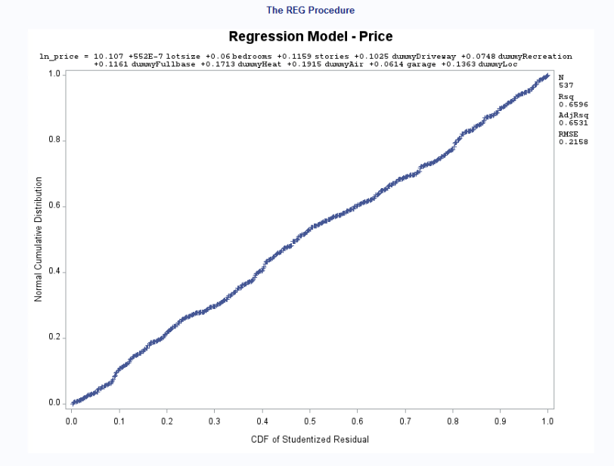

Figure 10

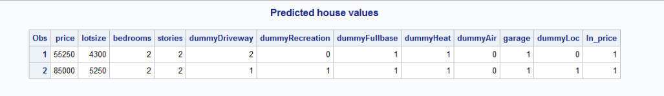

Figure 11

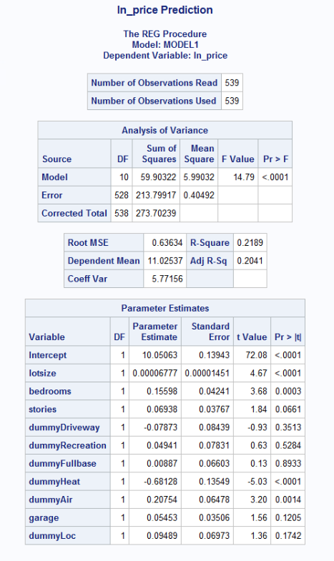

Figure 12

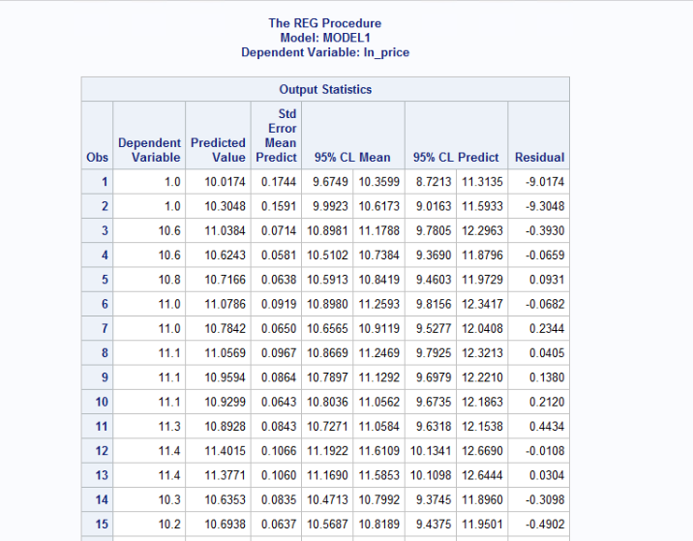

Figure 13

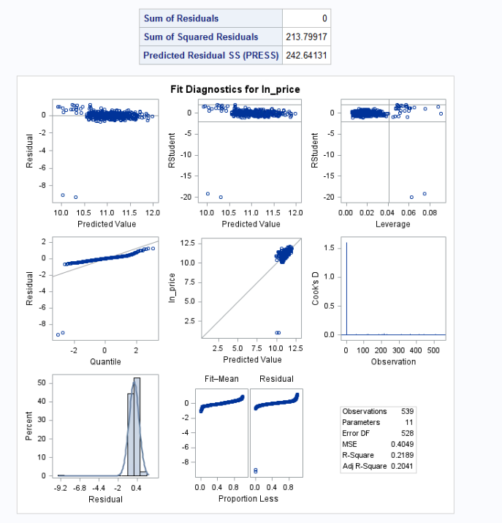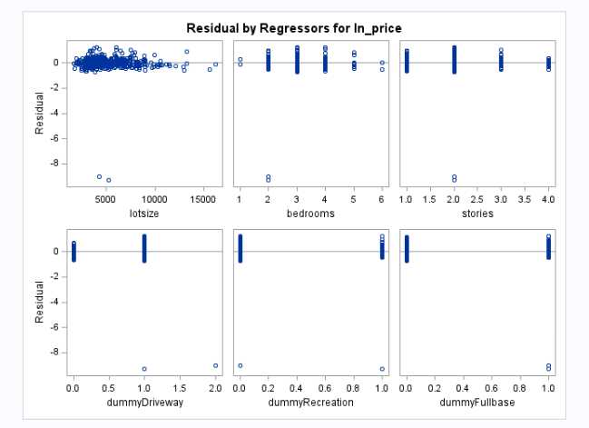

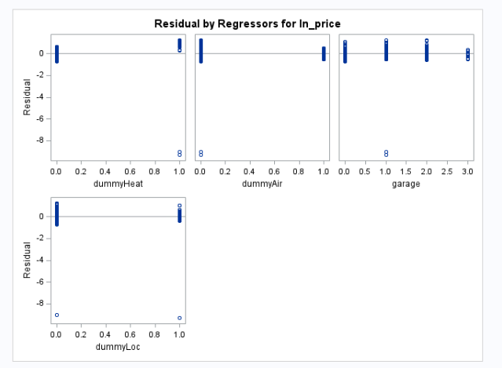

Figure 14

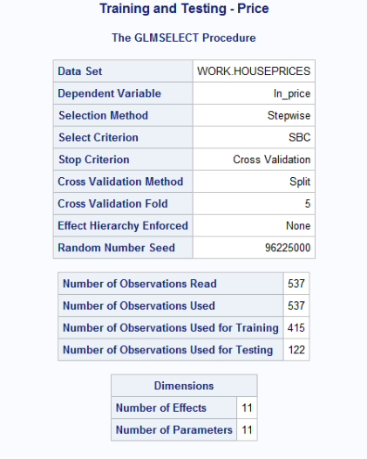

Figure 15

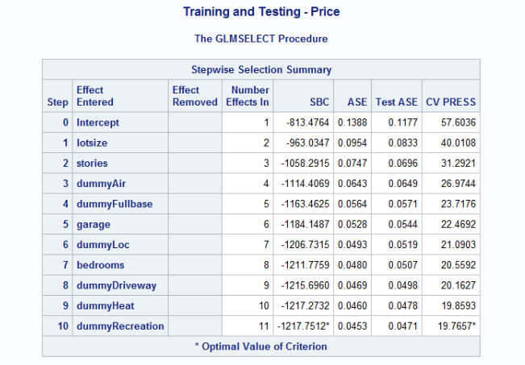

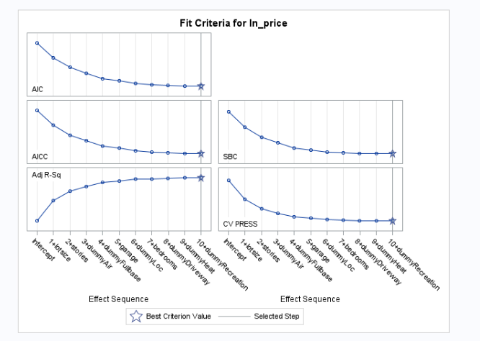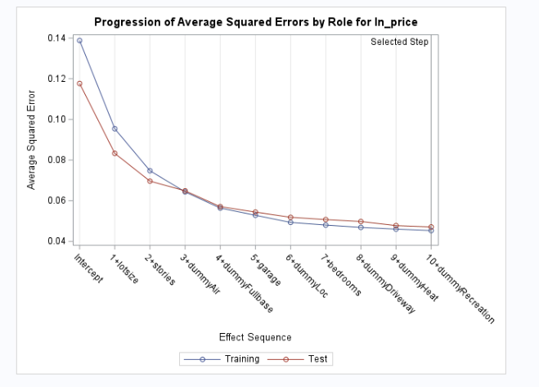

Figure 16

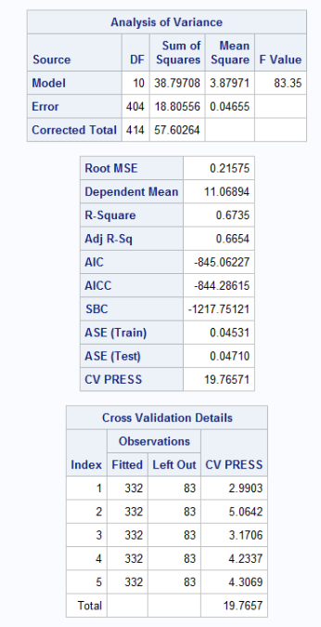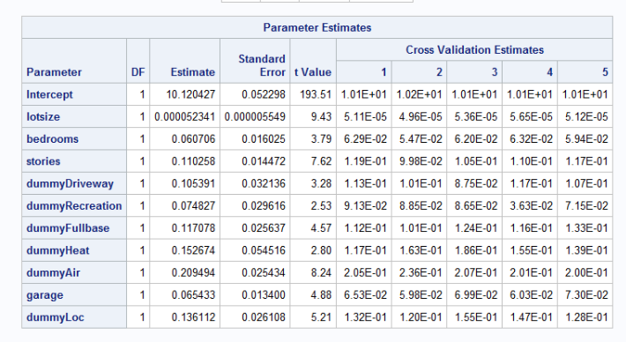

Figure 17

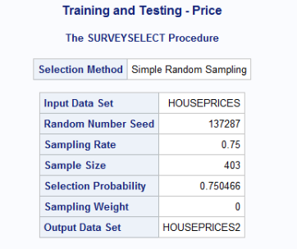

Figure 18

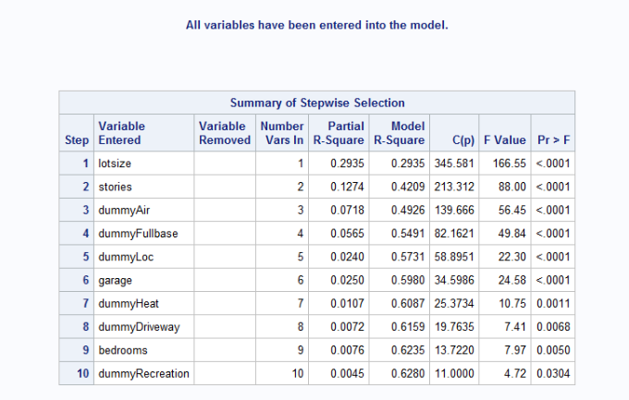

Figure 19

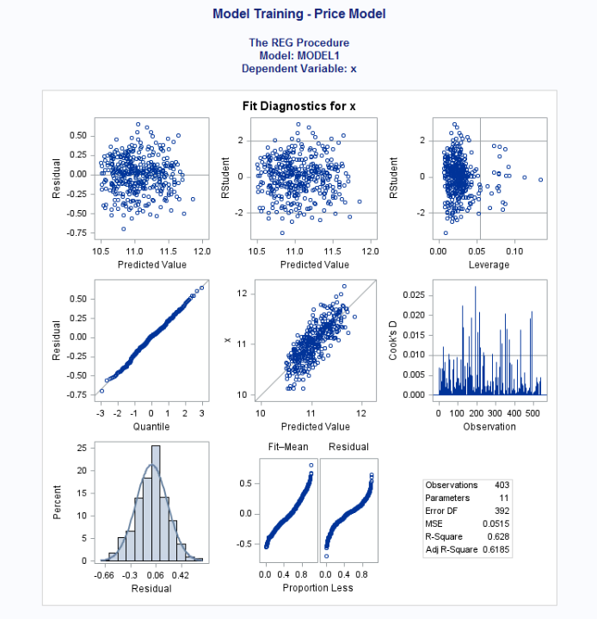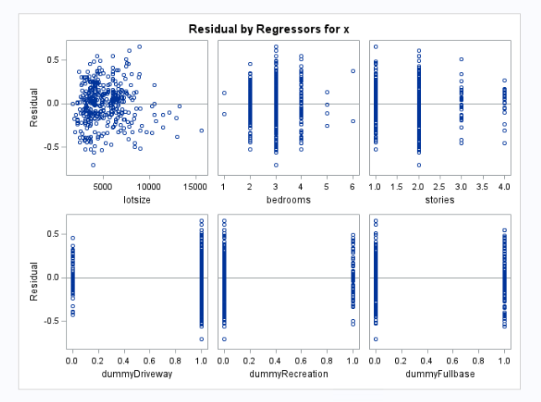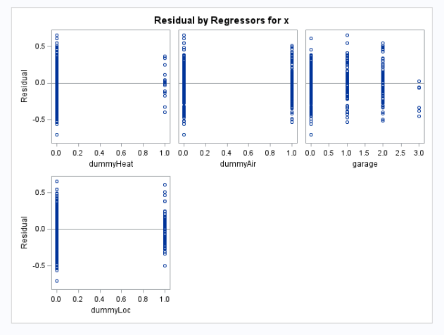

Figure 20

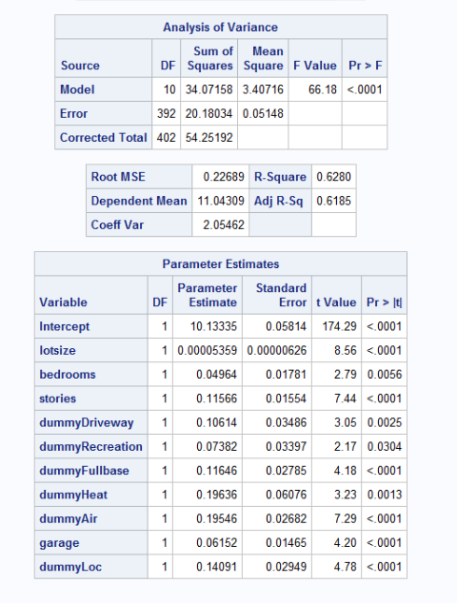

Figure 21

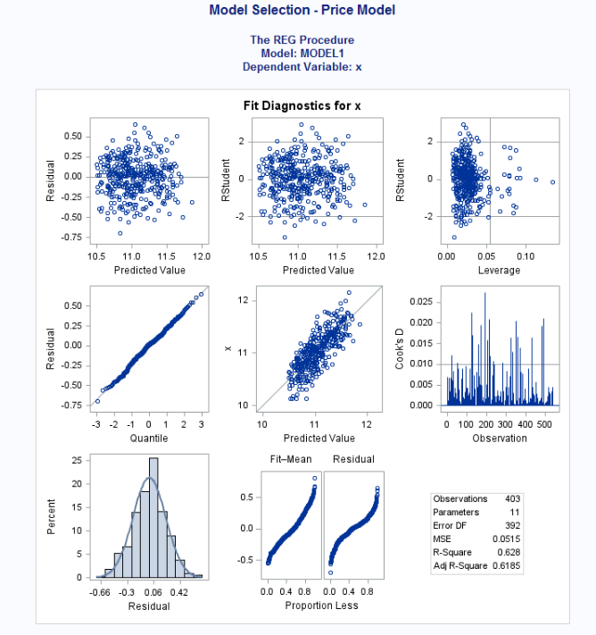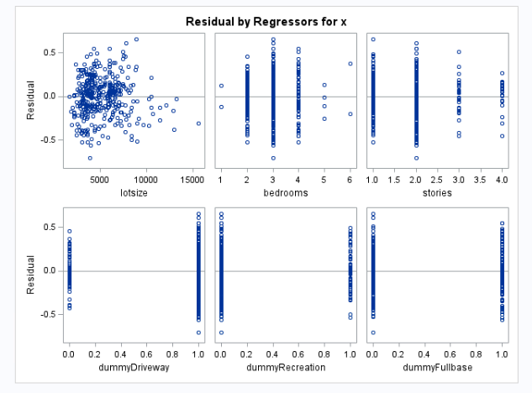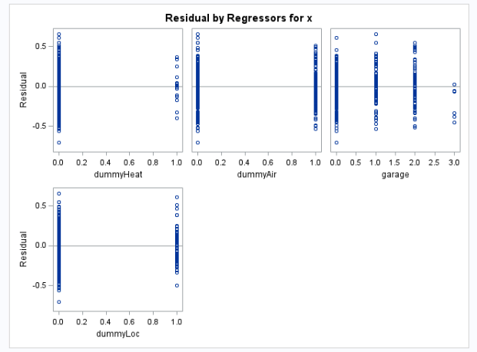

Figure 22

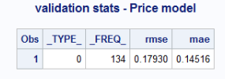

Figure 23

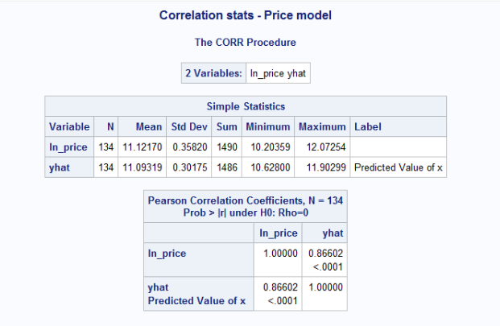

Figure 24